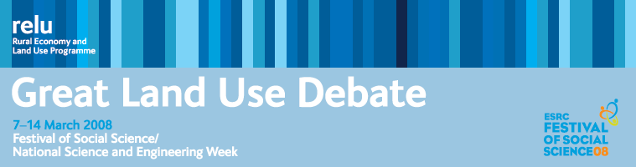

PRESS RELEASE

6 March 2008

SECRETARY OF STATE LAUNCHES ON-LINE LAND USE DEBATE

The Secretary of State for Environment, Food and Rural Affairs, Hilary Benn, is kicking off an on-line debate on land use in the UK and supporting the role of the UK Research Councils’ Rural Economy and Land Use Programme (Relu) in promoting an informed discussion on land use in the UK.

The Great Land Use Debate, which will go on-line on Friday 7 March 2008, at http://greatlandusedebate.wordpress.com/ is being hosted by Relu during the Festival of Social Science/National Science and Engineering Week. The Relu Programme began in 2003 to carry out interdisciplinary research on the multiple challenges facing rural areas. The debate will air opinions from key thinkers and invite everyone with an interest in land use to contribute.

The Secretary of State will say:

“We all have a stake in the countryside and it's important that we all have a say in its future. I am therefore delighted that Relu is launching this debate on rural land use as part of its contribution to National Science Week.

“As a society we need to take a fundamental look at how we use and value our rural land and what sort of countryside we want future generations to inherit. The rural environment provides us with a huge range of benefits: from food production to health and wellbeing; from wildlife conservation to water and flood management. It is also central to the challenge of climate change and has a really important role to play in both mitigation and adaptation.

“We therefore need a properly informed debate about how to get the best from our land, based on the most up-to-date evidence. I believe that Relu has a key role to play in this. In particular, we need to work towards a consensus on how we can use land, not just for one purpose but to achieve multiple benefits - for communities, for the environment and to meet our economic needs. There are already many excellent examples of this, such as Community Forests and work to restore our upland peat bogs. We need to learn lessons from this practical experience and from what science and economics can tell us about future land use trends and pressures. These are the issues which Defra's Land Use Project is exploring, and I hope this debate will make a significant contribution to that project and our thinking on the future of land, both urban and rural."

Click onto http://greatlandusedebate.wordpress.com/ from Friday 7 to Friday 14 March to read contributions from key thinkers and to have your say.

Notes for editors:
1 The UK research councils’ Rural Economy and Land Use Programme was launched in 2003 to carry out interdisciplinary research on the multiple challenges facing rural areas. The programme is an unprecedented collaboration between the Economic and Social Research Council (ESRC), the Biotechnology and Biological Sciences Research Council (BBSRC) and the Natural Environment Research Council (NERC). It has a budget of £24 million, with additional funding provided by the Scottish Government and the Department for Environment, Food and Rural Affairs. See www.relu.ac.uk.
2 The Festival of Social Science is organised by the Economic and Social Research Council, and runs from March 7th to 16th, alongside National Science and Engineering Week), in order to highlight just how integral the social sciences are to the wider world of science and engineering. It celebrates some of the very best British social science research, as well as highlighting the ways in which social science makes a difference to everyday lives. Press releases detailing some of the varied events are available at www.esrcfestival.ac.uk or for more information about the Festival please contact the ESRC Press Office on 01793 413032 or via e-mail: esrcpressoffice@esrc.ac.uk.
3 National Science and Engineering Week, which runs from 7-16 March 2008, takes science to the public rather than waiting for the public to find science. During the week, events are organised throughout the UK by a large and varied range of organisations and individuals including hospitals, schools, industry and museums, with venues ranging from shopping centres to pubs and churches. National Science and Engineering Week is coordinated by the BA in partnership with the Engineering and Technology Board (ETB), and funded by the Department for Innovation, Universities and Skills (DIUS). For more information, please visit www.the-ba.net/nsew
4 For more information about the Great Land Use Debate, contact Science Communications Manager Anne Liddon, tel 0191 2226880 or email anne.liddon@ncl.ac.uk.
ends

